**Information Technology Institution**

**Intensive Training Program**

**Data Analysis Track**

**Power BI**

**Shows Datasets**

Submitted By:

**Mohammed Adel Eltohamy**

**Hossam Mohamed**

**Mohammed Arafa**

Table of Content

1.0 About Datasets 3

2.0 Data Cleaning 3

3.0 Measures & Tables created 4

4.0 Data Modeling 4

**4.1.0 Another examples for modeling** 6

5.0 Dashboards 7

**5.1.0 Amazon Prime Dashboard:** 7

**5.2.0 Disney Plus Dashboard** 8

**5.3.0 Netflix Dashboard** 8

**5.4.0 Netflix Subscription fees Dashboard** 9

**5.5.0 All platform shows Dashboard** 9

# About Datasets

### Datasets Contain of three main tables about the shows provided in three different platforms (Netflix, Amazon Prime, Disney Plus ). There is also fourth table that contain information about different types of fees for Netflix platform in different countries.

### We clean, transform, model & merge tables in dataset to Design a meaningful and representable Dashboards that contain important information about (Type of shows, releasing year, shows nationalities, duration for each show…. etc.).

# 2.0 Data Cleaning

### Import data and delete empty rows

### Split Country, Cast & Genre

### Unpivoting for Country, Cast & Genre columns.

### Remove duplicate from rows.

### Remove the Show_Id column when merge the three datasets.

### Add New indexing column to the merged datasets.

### Replacing Null values in columns.

# 3.0 Measures & Tables created

### Tables Created:

### Date table: Contain (date, Month, day, year, Quarter)

### Measures created:

### Measures to calculate distinct No. of directors (Directory No.).

### Measure to Calculate total No. of Shows (All Shows).

### Measure to Calculate the average of different type of fees (Cost).

### Measure to Calculate the average No. of TV shows, movies & libraries in each country (Shows).





# 4.0 Data Modeling

### Example: Amazon prime data.

### Fact Table: amazon_prime_title

### Dimension tables:

### Cast Dimension

### Show Type Dimension

### Date Dimension

### Directory Dimension

### Country Dimension

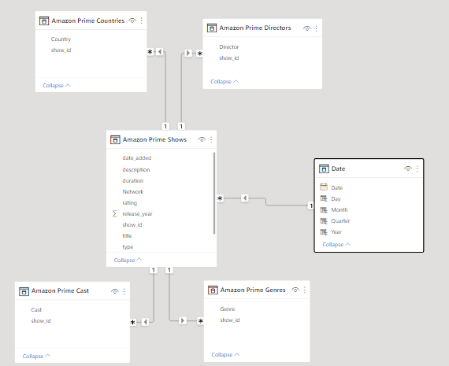

## **4.1.0 Another examples for modeling**

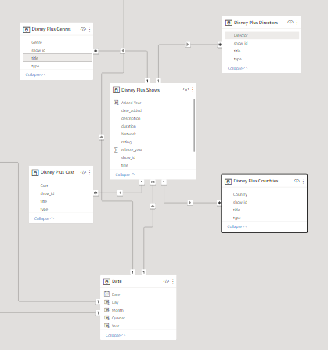

# 5.0 Dashboards

### Information had been Showed in dashboards:

### Slicers: (Shows type, Years, Country)

### Durations (TV shows per season, Movies per Min)

### Rating categories

### Show add per years

### Shows genre

### Number of shows & directors

### Shows nationalities (Country)

### Average basic fee, Average standard fee & Average premium fee

